**Model 1**

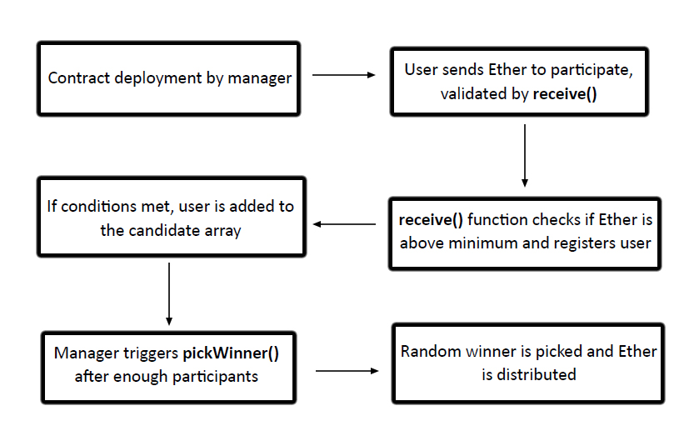

Fig.1 Structure of Smart Contract in Model 1.

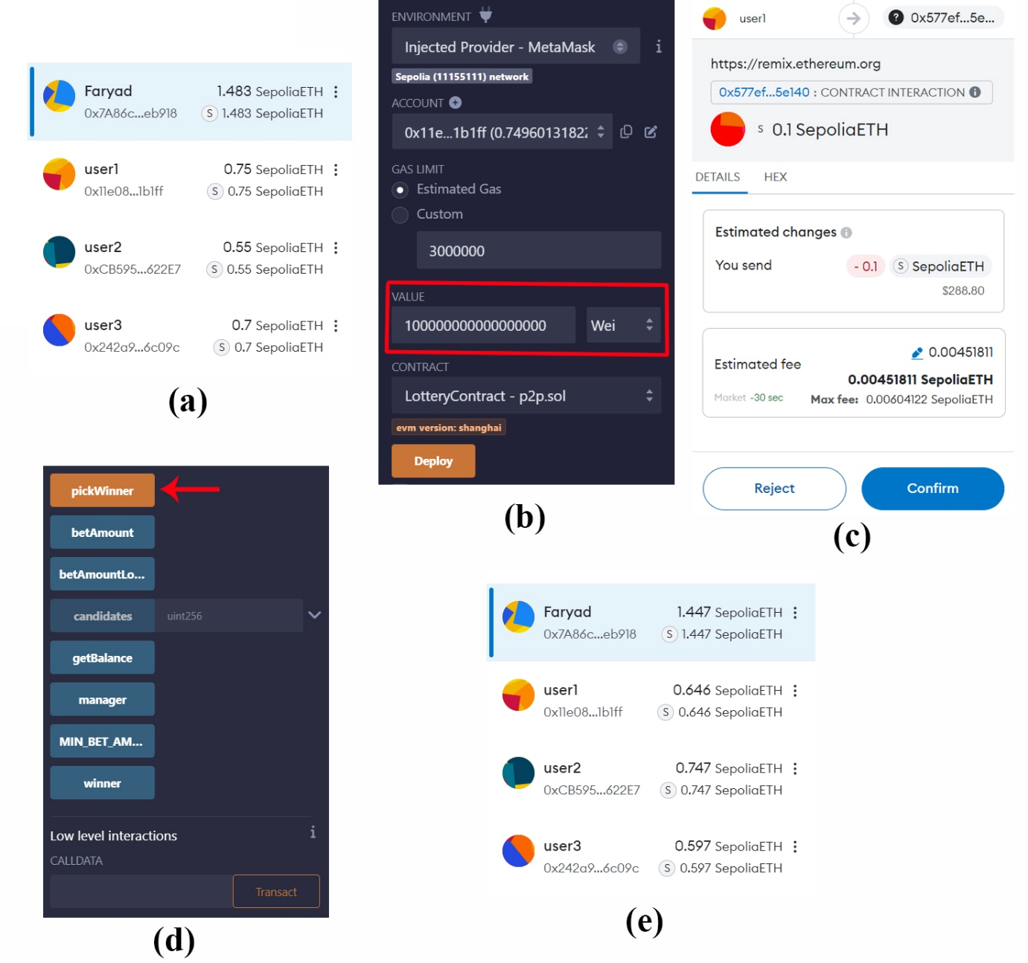

Fig.2. Screenshot of Remix and Metamask before and after executing Smart Contract in Model 1:

a. metamask screenshot before executing SC1. b. each user placed 0.1 Ether. c. user must confirm transaction through metamask. d. after placing all bets, manager execute Pickwinner function. e. metamask screenshot after executing SC1, user2 won the game.

**Model 2**

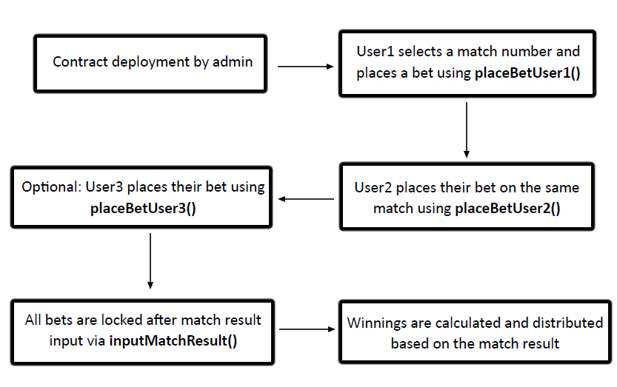

Fig.3 Structure of Smart Contract in Model 2.

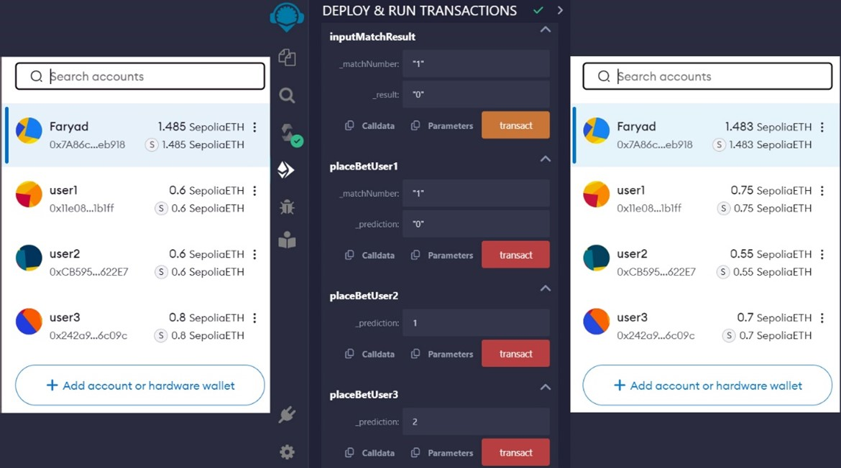

Fig.4. Screenshot of Remix and Metamask before and after executing Smart Contract in Model 2: Initially, the account balances reflect the amounts prior to the bet settlement. After the contract execution, where user1 is set as the winner based on the match result, the changes in account balances are evident: user1's account increases by the total bet amounts placed by user2 (0.05 ether) and user3 (0.1 ether), totaling an increase of 0.15 ether.

**Model 3**

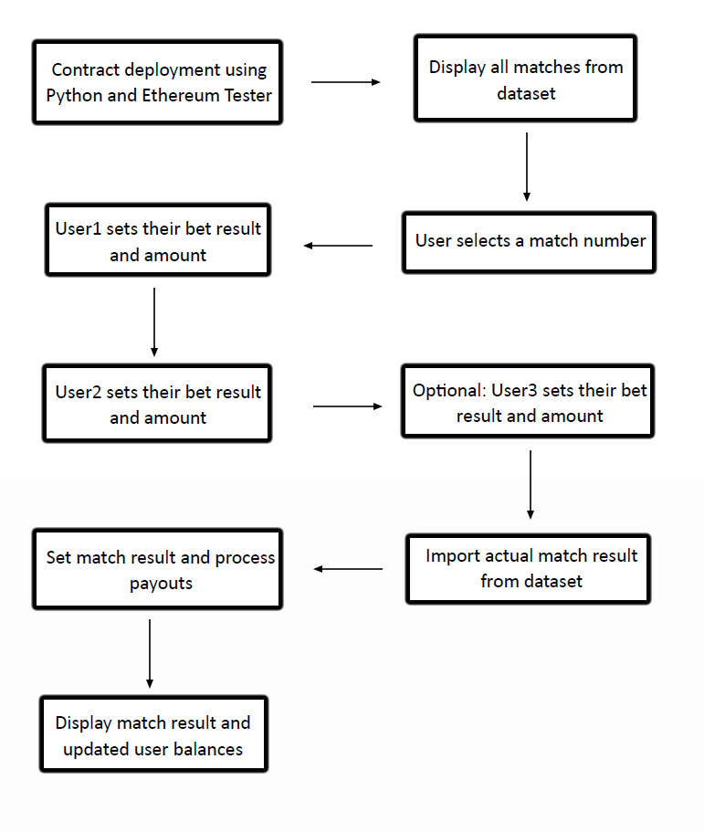

Fig.5 Structure of Smart Contract in Model 3.

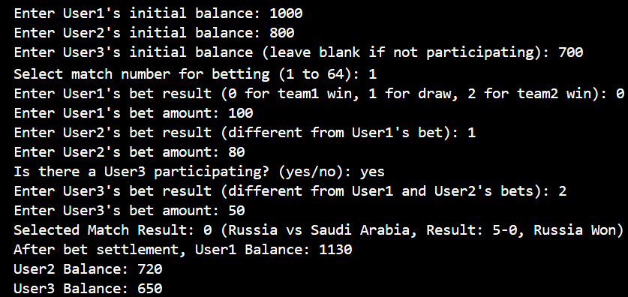

Fig 6. Python output displaying user interactions and results for Model 3. user 1 initiates the betting process by selecting match number 1 from the dataset of 64 matches, setting their preferred outcome, and a bet amount. User2 and an optional user3 follow suit by choosing their outcomes and respective bet amounts. The Python script then imports the actual result of the selected match from the dataset. The output displayed confirms the match result, identifies the winner, and updates the account balances to reflect the transfer of funds in accordance with the bet outcomes.

Table 1. Comparative overview of the three developed models

|  |  |  |  |
| --- | --- | --- | --- |
| **Feature** | **Model 1: Random Game** | **Model 2: Sports Match Prediction** | **Model 3: Sports Match Simulation** |
| **Deployment Environment** | Ethereum Test Net | Ethereum Test Net | VM (Virtual Machine) |
| **Interface** | Remix | Remix | Python |
| **Data Integration** | No | Manual Input | Yes (from Dataset) |
| **User Interaction** | Minimal | Moderate | High |
| **Transaction Simulation** | Yes | Yes | Yes |
| **Purpose** | Demonstrate random outcome | Simulate sports betting | Integrate real-world data |